Mehran University of Engineering and Technology Shaheed Zulfiquar Ali Bhutto Campus, Khairpur Mir’s Department of Software Engineering

**Course: Software Design & Architecture SW-227 (Practical) - Instructor: Engr. Shamshad Naveed**

# Lab No. 09

**Objective: To implement Decorator Design Pattern**

|  |  |  |  |  |
| --- | --- | --- | --- | --- |
| **Name:** | **Mohammad Ibraheem** | **Roll Number:** | | **K20-19SW31** |
| **Score:** | **Signature:** | **Date:** | **25-09-2022** | |

|  |  |  |  |  |  |  |  |
| --- | --- | --- | --- | --- | --- | --- | --- |
| **LAB PERFORMANCE INDICATOR** | SUBJECT KNOWLEDGE | DATA ANALYSIS AND INTERPRETATION | ABILITY TO CONDUCT EXPERIMENT | PRESENTATION | CALCULATION AND CODING | OBSERVATION  /RESULTS | SCORE |
|  |  |  |  |  |  |  |  |

**Task :** Implement Decorator Design Pattern

Code:

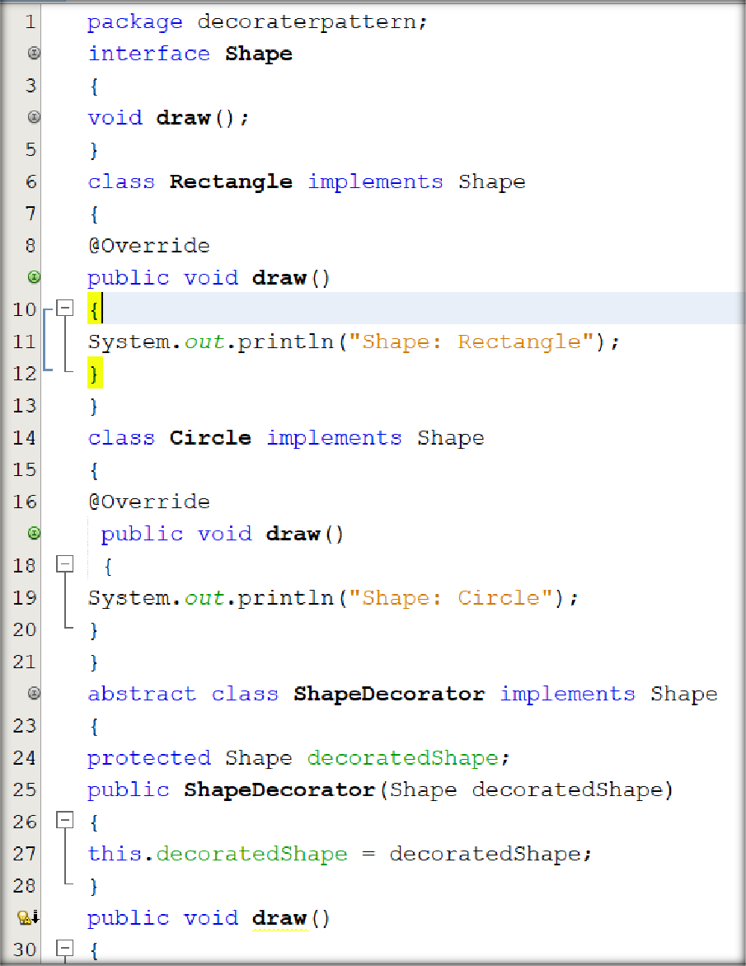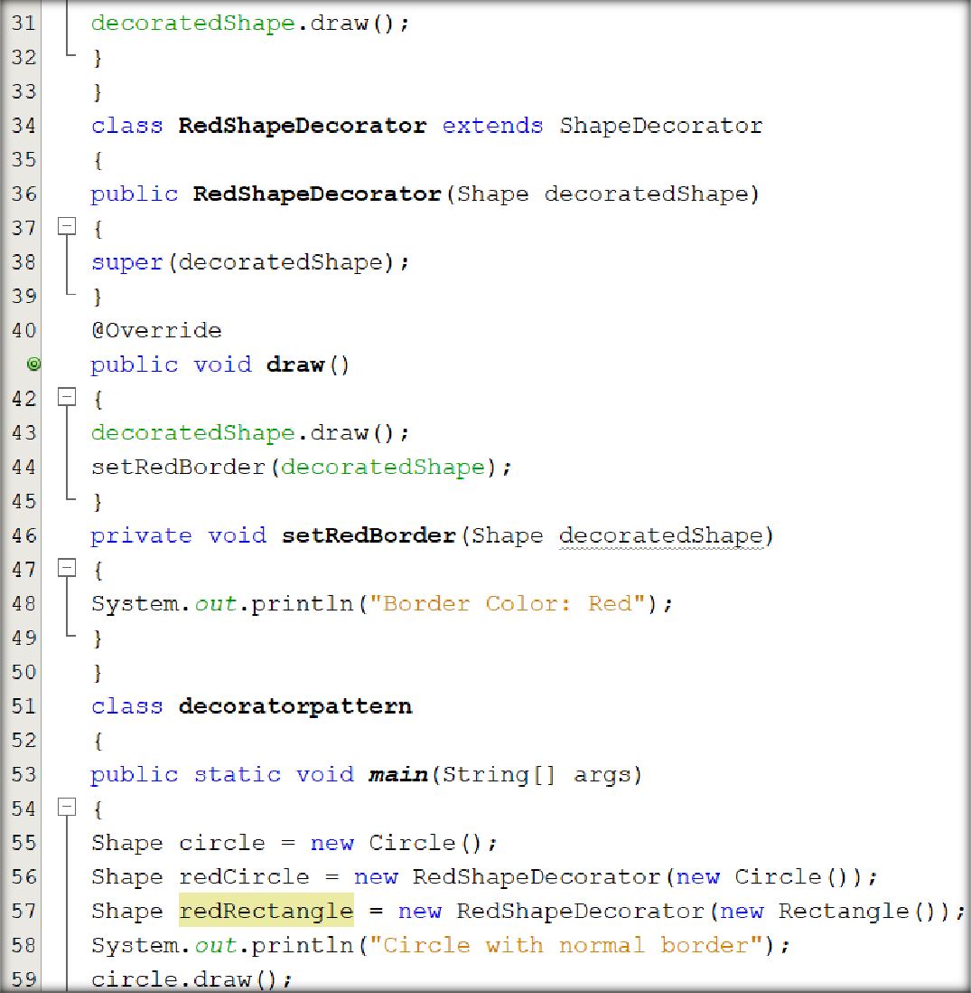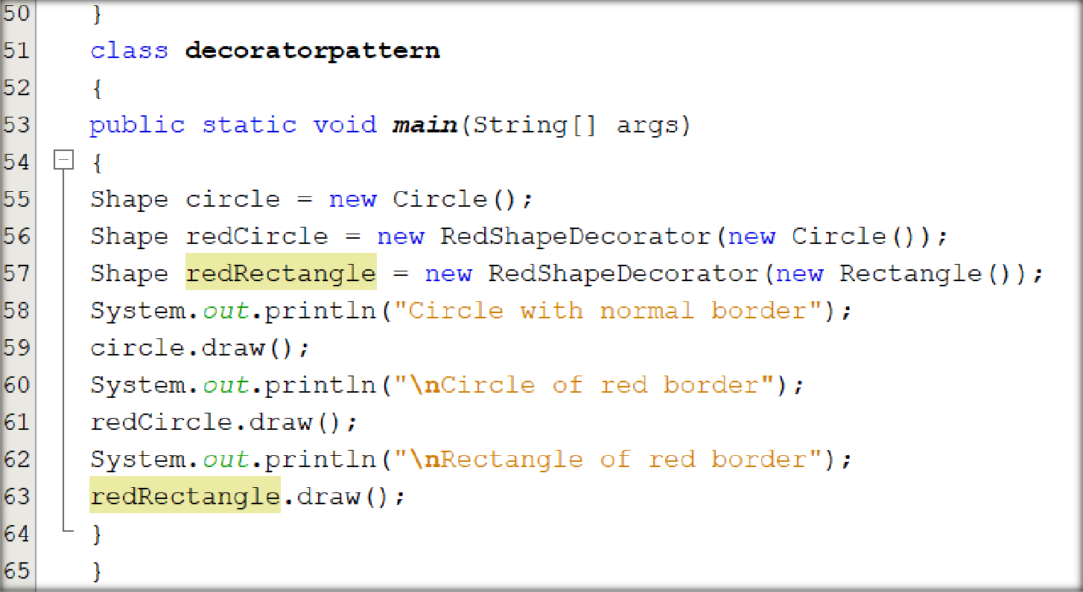

# Output:

